APPLICATION OF THE INTERNET OF THINGS IN GAME DEVELOPMENT AND INTERACTIVE TOYS: A COMPREHENSIVE REVIEW AND FUTURE DIRECTIONS

A dissertation submitted in partial fulfilment of the requirements for the award of the degree of bachelor’s in liberal arts.



Faculty Supervisor
Dr. K. Sathesh Kumar
Associate Professor
Computer Science and Engineering

Aditya Vijayaragavan Naidoo
2022BALA07ALA006
2022-2026

Acknowledgment
I acknowledge that I have completed this research work under the supervision of my mentor, Dr. K. Sathesh Kumar. I extend my gratitude to Dr. Kumar for his insightful advice and guidance throughout the process. I also acknowledge the aid of Alliance University for providing me with the academic resources I required. The access to scholarly materials, institutional support, and academic guidance contributed to the completion of this paper. I also acknowledge the use of Artificial Intelligence for creating a conceptual design. AI was used to generate images of conceptual game interfaces and frameworks.
Abstract
IoT is used in Game Development and Interactive toys for various design reasons. It has changed the way players interact with the game, and sometimes even targets a specific set of players with added benefits like exercise or gaining skills and experience.
IoT has been used to create simulations for medical and nursing education (de Ribaupierre et al., 2014). The simulations used as educational tools have improved cognitive skills and created a fun learning environment despite the repetition of the same procedure (de Ribaupierre et al., 2014). On the other hand, IoT-based games are used for rehabilitation, making the process more immersive and doable (Arango-Lopez et al, 2019). There are many different types of games that use IoT, some of which fall under different categories, which confuses the different kinds of games developed using IoT (Carneiro et al, 2024). IoT-based games are a separate category that is based on the concept of human-computer interaction (Carneiro et al, 2024). Pervasive games feature a mixed environment of digital and physical features in the game’s interface. One use case of pervasive games is rehabilitation. Serious games are pervasive games that are used for educational purposes, such as simulating surgeries for medical students.
IoT is also used in interactive toys. Interactive toys use sensors and actuators to interact with their users. Most interactive toys learn from experience, adapting to the way they are interacted with by their users. They have mobile applications to enable communication and other features. Interactive toys can also be emotionally intelligent, like the LOVOT. Lovot is an emotional support pet robot designed in Japan, capable of reading expressions and understanding its users' needs. LOVOTs can sense the touch of the user and respond to it with body language and non-verbal communication (Hung et al, 2025).

Contents
Introduction 1
Literature Review 3
Interactive Robots 3
Cozmo Robot 3
LOVOT 4
Phygital Object 4
Pervasive Games 4
Ethical Concerns 5
Misconception in the field and what to correct 6
Research Objective 7
Methodology 8
Findings 9
Use of IoT in Game Development and Interactive Toys 9
Stakeholder Benefit 10
Discussion 11
Another take on how IoT can be used in Game Development 11
IoT Network Architecture 11
Gameplay 11
ER Diagram 13
Entities 13
Conclusion 22
Appendix 25

Chapter I

Introduction
The Internet of Things (IoT) is a growing technology, expanding its domain into many industries. IoT has emerged as a key concept in enabling efficient management of smart cities, home automation, and healthcare applications. The seamless interaction of devices in a network has caught the attention of many industries as it aids in communication, understanding the environment, and the ease of managing applications virtually from other regions. Lately, IoT has begun to shape the game development and interactive toys industries.
Modern-day game developers are using IoT technology to enhance the gameplay experience. Game developers have started experimenting with new ways for players to interact with the game, such as physical game pieces, unique sensors and actuators on the controllers, and VR headsets instead of game consoles. PS5 DualSense controllers are equipped with Gyro sensors, ‘DualSense haptic feedback’ actuators, and a touchpad, allowing for new ways to narrate the story of the game. The controller can be flipped upside down, use the touchpad to write letters, and vibrate in many ways to stimulate different feelings (Sony, 2026). Games like ‘Skylanders: Spyro’s Adventure’ use physical game pieces, which resemble characters that can be used on PS3, Xbox 360, and Wii (Coulton et al, 2013). Coulton et al. state that the characters can store data about what they have in their inventory and what skills they can use. Developers venture into the VR headset game space to make immersive gameplay, creating games like ‘Arashi: Castle of Sins’, Hitman 3, and Zenith (Laghari et al, 2025; Sony, 2026).
As for interactive toys, designers embed the toy with multiple sensors, Bluetooth and/or Wi-Fi connectivity, and mobile applications to interact with the toy. Some interactive toys are made to be emotionally supportive, while others are capable of nurturing certain traits of children. The Cozmo bot comes with interactive blocks that are used in competitive games (Kay et al, 2023). While it is not interacting with its user, the Cozmo bot explores its environment and even interacts with the interactive block (Kay et al, 2023). The mobile application also has an exploration mode, which displays what Cozmo can see on the screen. On the other hand, LOVOTs are capable of understanding human emotion through their body language and touch (Hung et al, 2025). Hung et al. state that it responds to the user, tending to their emotional needs using non-verbal communication.
Game development and Interactive toys will continue to grow their dependency on IoT. Whether it is a new feature to a controller like the touchpad on the PS5 DualSense controller, a simulation used for education, or an emotional support robot, the use of IoT technology will only grow as it becomes cheaper to produce.
Chapter II

Literature Review
Game development and interactive toys are ever-changing industries that grow proportionally with the development of technology. The development of IoT has encouraged experimental and innovative games, changing the way players interact with games and improving the impact of the narrative of the game (Carneiro et al, 2024). With the expanding development of Virtual Reality (VR) games due to the development of hardware, the use of IoT has increased to enable users to interact with the environment (Choudhary et al, 2015).
Players use wearable devices and control devices to enhance their experiences (Laghari et al, 2025). Laghari et al. explain that wearable devices and control devices are equipped with sensors that are used to collect data or inputs, allowing them to interact with the game environment. On the other hand, actuators are used to enhance the interaction by providing players with sensory feedback, such as the texture or impact of an object (Laghari et al, 2024).

Interactive Robots
Most interactive robots are capable of understanding human emotion. They display their artificial feeling through eye expressions (Bakkar, 2024). They are exceptional at detecting emotions, allowing them to understand the user’s emotions and tend to their emotional needs (Bakkar, 2024). Some robots, with the help of Natural Language Processing and a microphone, are capable of conversation with their users. Interactive robots can analyse gestures to interpret emotion, sign language, and even gesture-based commands (Bakkar, 2024).

Cozmo Robot
The Cozmo bot is an interactive toy that includes three interactive blocks in its package (Kay et al, 2023). Cozmo also has a mobile application that can be used to interact with the toy. The mobile application can also be used to program the toy. Cozmo can interact with its targeted audience in many ways. The robot can play games with the user, which makes use of the interactive blocks (Kay et al, 2023). The mobile application also has an exploration feature, allowing the user to experience the world from Cozmo’s perspective through the camera installed on it (Kay et al, 2023). Cozmo can also learn skills on its own, such as stacking the interactive blocks on top of each other. The engagement with the user teaches both Cozmo and the user a lot, making it a good tool for child development. Cozmo provides a good environment for children, though children are partially aware of the interactive toy’s limitations (Kay et al, 2023). The games that arrive pre-installed on the robot nurture competitiveness and curiosity (Kay et al, 2023).

LOVOT
LOVOT is an emotional support pet robot designed in Japan. They are capable of reading expressions and understanding their users' needs. Since LOVOT communicates non-verbally, through actions such as cooing and purring, they break language barriers (Hung et al, 2025). This form of communication makes LOVOT accessible to speakers of any language and people with cognitive impairments (Hung et al, 2025). LOVOTs are designed to understand their users’ emotional and social needs (Hung et al, 2025). They can sense the touch of the user and respond to it with body language and non-verbal communication.

Phygital Object
The game development industry is constantly evolving with technology and consumer preferences. Some game developers try to embed new technologies into their video games. ‘Phygital objects’ are interactive tools that can be used as physical game pieces, enhancing the experience of virtual games (Coulton et al, 2013). Coulton et al. claim that ‘phygital objects’ can unlock new characters, a new storyline to the game, and save your progress. It blurs the boundary between toys and games by intensifying the player’s interaction in the digital world using physical objects. However, using phygital objects in the game would mean the player would have to purchase the item physically, which decreases the affordability of the game (Coulton et al, 2013).

Pervasive Games
Over the past couple of years, the gaming industry has begun to explore and develop the concept of pervasive games. Pervasive Games feature a mixed environment of digital and physical elements. For instance, Pokémon Go is a pervasive game where players catch Pokémon in augmented reality (Majgaard & Larsen, 2017). Pervasive games have been used in the medical industry to make the rehabilitation process satisfyingly engaging.
Rehabilitation is a physical and/or mental recovery process to enable or enhance a patient’s ability to do basic daily tasks (Shapi'i et al, 2015). It can be exhaustive and boring at times as the exercises are repetitive. Pervasive games have the ability to make the rehabilitation process more engaging, amplifying the patient’s motivation to participate (Arango-Lopez et al, 2019). Shapi'i et al. argue that multiplayer pervasive games are more effective, as patients can play with other players when it is hard to find someone to play with.
Serious games are pervasive games used for educational purposes by improving vocational and cognitive skills. It is used in fields such as aviation, medicine, or nursing. De Ribaupierre et al. had developed a serious game targeted at Orthopaedic surgeons that simulates the Total knee arthroplasty procedure. Although the technology was recently invented, medical and nursing curricula already feature serious games for practicing medical procedures through roleplay or the use of mannequins (de Ribaupierre et al, 2014). Over time, with the aid of technological development, digital simulations were developed, recreating the situation and environment. It enabled the simulation of more complex procedures, such as the z-plasty surgery, and the Off-Pump Coronary Artery Bypass (OPCAB) surgical procedure (de Ribaupierre et al, 2014).
Like all games, pervasive games also have communities that discuss experiences and glitches. Majgaard, G, & Larsen, L.J call such communities ‘pervasive learning communities’. Pokémon Go has a few online and virtual communities that discuss and learn from the experience of other players (Majgaard & Larsen, 2017).

Ethical Concerns
IoT devices are loaded with sensors to collect data about their surroundings. Some sensors used in pervasive games and interactive toys can track noise, location, touch, and movement. In the hands of innocent consumers like children, such products increase their vulnerability (Holloway & Green, 2016). IoT systems are prone to hacking, inducing concerns about the user’s data privacy and security (Holloway & Green, 2016).

Misconception in the field and what to correct
Carneiro et al. state that, given the similarities between many new types of games, there are common misconceptions about what type of game the paper is focused on. Carneiro et al. emphasize their focus on Human-Computer Interaction (HCI) within the ‘games and gamified systems’. IoT games require a link between the physical realm (physical objects and the environment) and the digital experience (Carneiro et al, 2024). Though Carneiro et al. are right, this paper will still explore the use of IoT in each case, treating them all as IoT-based games.

Chapter III

Research Objective
The objective of this research is to investigate the various ways in which IoT is used in game development and interactive toys. The research aims to understand how interconnected devices, sensors, and real-time data exchange can affect the gameplay experience. The final portion of the research aims to devise a new way to use the Internet of Things to design cross-device gameplay. This method can be used to narrate different game objectives across different devices. The method will also require a player to use a card that will be used to grant them access to their Avatar through Near Field Communication (NFC).

Chapter IV

Methodology
This dissertation is a research-oriented project that analyses a series of research papers related to the topic. The research is divided into three parts. Parts 1 and 2 will be included in the findings chapter, and the third part will be included in the discussion chapter.
For the first part of the research, it will explore the use of IoT in Game development and Interactive toys, exploring the components involved and design architecture. It will investigate the network architecture of an IoT system. Diving deeper, the research work will explore how each layer of the network architecture is used in Game Development and Interactive toys.
In the second part, the research will analyse how the products in the literature review segment have benefited or had an impact on the consumers. It will explore the impact of the products mentioned in the other works, such as the simulations used by medical students, pervasive games used for rehabilitation, LOVOT, and Cozmo.
In the third and final part, the research will try to devise a new method for how IoT could be used in game development in the future. This new method will narrate different objectives of the gameplay on different devices. To explain how this works, the research work takes inspiration from Dungeons and Dragons, a storytelling board game that relies on a narrator known as the Dungeon Master and a set of 7 dice that includes one of each type. The types of dice are D4, D6, D8, D10, D%, D12, and D20. The method will use a Near Field Communication (NFC) card, similar to how the character figures are used in ‘Skylander: Spyro’s Adventure’. However, unlike the character figures and the base the player places the character figure on, which uses RFID technology, the NFC card can directly communicate with the device as long as it is in close proximity to the device the player desires to play on.

Chapter V

Findings

Use of IoT in Game Development and Interactive Toys
The Internet of Things in a general sense, has 5 conceptual layers that perform different tasks of the IoT System. The first layer is the sensing and device layer, which is used to attain information about the physical attributes, such as light or distance, in a limited space known as the environment. It also consists of the physical device used in the IoT system. The second layer is the IoT gateway layer, which communicates the information to other devices in the network. The other devices can gather information from the collected data or refine the data to store it in a database. The third layer is the network layer, which is capable of spreading the information to the rest of the internet. The fourth layer is the cloud layer, also known as the server layer, which allows the information to be stored on the internet to be used by other netizens. The cloud layer is also capable of using the information to predict future outcomes or retrieve parts of the information that would be useful to the user. The final layer is the application layer, which can be used to visually represent the information to the end user of the IoT system or netizens.
Figure 1.1 shows the 5 conceptual layers with respect to game development. It shows how the sensing and device layer consists of devices that are used to play the game and the sensors required to interact with the game. The IoT gateway layer, as illustrated by Figure 1.1, is used to process the gathered data and manage the interaction of the sensors and devices that are currently in use. The network layer, as illustrated in Figure 1.1, is capable of real-time communication between the IoT system and the cloud/server. The cloud/server, as illustrated by Figure 1.1, is used to process the information and provide feedback to the player in the form of progress in the gameplay. The application layer, as illustrated by Figure 1.1, is used to visually represent the consequences of the player’s actions. It is also used to provide the player with information such as player ranks, the profiles of other players, and the player’s experience.
Figure 1.2 shows the 5 conceptual layers with respect to interactive toys. In the case of interactive toys, the toy is embedded with sensors that gather data about the toy’s environment in the sensing and device layer, as illustrated by Figure 1.2. As illustrated by Figure 1.2, the data is processed by the microcontroller within the interactive toy in the IoT gateway layer. As illustrated by Figure 1.2, the network layer connects the interactive toy to the local wireless network to communicate with other devices, such as a smartphone or a tablet. As illustrated by Figure 1.2, the cloud/server layer is used to compute the data about the user’s interaction with the interactive toy, generating information about what the interactive toy learns and how the user prefers to interact with it. As illustrated by Figure 1.2, the application layer contains the user interface of the mobile application used to interact with the interactive toy.

Stakeholder Benefit
Many IoT-based games are driven by a purpose as a solution to a problem, while other games may be purely entertainment. Serious games used for medical education have proved to increase the cognitive skills of medical students within an engaging environment (de Ribaupierre et al, 2014). The simulations provide an environment where students can practice complex procedures repeatedly without the real-world consequences of failure. For instance, the Total Knee Arthroplasty (TKA) simulation aids surgical residents in learning the logical sequence of the procedural steps and tool selection, which allows them to focus purely on technical execution when they eventually enter a real operating room. On the other hand, pervasive games are used for rehabilitation to increase the participation of the patient (Arango-López et al, 2019). The immersive experience makes the process less tedious and increases engagement, enabling the patient to recover completely (Arango-López et al., 2019). Some Pervasive Games have a multiplayer mode that reduces the feelings of isolation often felt by patients who find it difficult to find daily companions for their exercises.
Similarly, Interactive toys are driven by a certain purpose intended to aid a targeted audience. The LOVOT is designed to provide joy, acceptance, and be an exceptional social companion tending to the user’s emotional necessity (Hung et al., 2025). Because LOVOTs communicate through non-verbal communication and body language, they are highly inclusive for older adults who are socially isolated or have cognitive impairments (Hung et al., 2025). Likewise, Cozmo is capable of instilling curiosity, creativity, and a competitive nature within children (Kay et al, 2023). Cozmo has built-in games that utilize the interactive block that the toy comes packaged with, improving the child’s skills (Kay et al, 2023).
Chapter VI

Discussion

Another take on how IoT can be used in Game Development

IoT Network Architecture
An Interesting way to use IoT would be to make a cross-platform open-world video game, in which different devices narrate different parts of the story or have different objectives in the game. In each device of this form of gameplay, the player will experience different parts of the storyline. As shown in Figure 2, the devices are connected to their player’s Local Area Network. Through the router, the device stores, receives, and manipulates data from a server where the data of millions of players is stored. To access the character’s data from the server, the player must use the character card. The character card uses NFC technology to allow the user to access the character used by the player.
For instance, to break down how such a system will work, take Dungeons and Dragons (DnD) as a video game. DnD is a narrative board game consisting of a Dungeon Master and 3 to 5 players in a party. The dungeon master is responsible for narrating the story while players try to solve problems during their adventure using their characters’ skills. A dice is used to evaluate how effective the plan is and what consequences the players face when the plan doesn’t work. At the end of the adventure, the players may gain experience, new skills, or new equipment. The fate of the players depends on the dice and the Dungeon master’s narration.

Gameplay
In a video game, the narrative remains, but the probability vanishes. Players can attack hostile creatures and rival parties in a multiplayer open-world role-playing game. Instead of a Dungeon Master, the story unfolds by interacting with Non-Playable Characters (NPC) and going on quests with guild members assigned by a NPC in the guildhall. In the PC and Console narrative of the game, the player receives quests from an NPC and venture out with other guild members. Figures 3.1, 3.2, and 3.3 are a few biomes in which the players will encounter Friendly and hostile NPCs which they will interact with during their quest. Some quests may also require parties of a guild to save a friendly NPC, as shown in Figure 3.1. Guilds are even given types such as the builder’s guild, potion’s guild, Adventure guild, etc., which would determine the type of quests the guild will take up. Guilds can also receive requests from other guilds of different types. For example, in Figure 4, one can see that the Adventure’s guild, known as ‘Stormriders’, has given a potion guild the request to make healing potions. Figure 5 shows a village as part of the map of the Console and PC Narrative. Villages can be part of the original map or built by guilds using the VR headset narrative. The game can contain specific spots where the guilds can build villages. Guilds can also fight other rival guilds to conquer these specific spots or build an alliance by building separate guildhalls on different sides of the player-built villages. Figure 6 shows the most entertaining part of the Console and PC narrative. It is a sample visual of the dungeon in which the guilds can find treasure and fight hostile NPCs to gain experience. Exploring dungeons can be a Guild’s quest or a party's free roam adventure to gain experience and new skills.
As for the objective of the mobile game, the objective is to find the resources for guild quests. As shown in Figure 7, the players can roam around the real world, just like in Pokèmon Go, to loot chests, and collect raw materials by mining ore or wood by cutting trees. Players can even place a personal chest on the ground, which can be accessed by the player or other guild members. If the player has to many objects and hopes to continue collect resources, the character can keep objects in the chests and continue collecting more objects. However, the player can only continue to open chests and collect resources as long as they have enough stamina. Stamina continues to deplete as the player walks, opens chests, and collects raw material. In the mobile game, there are also hostile NPCs that steal loot from players. To evade these NPCs, the player can fight the NPC using the traditional probabilistic method. The player will be given a couple of options to fend off the NPC. These options would consider the weapon collected from chests and skills obtained in the Console and PC narrative. Another option is to escape the hostile NPC, which will further deplete the stamina of the player. If the character fails, the character can lose stamina and raw material to the NPC.
In the VR headset narrative, the user can build Ships for a fishermen’s guild, other guildhalls, and safe houses. As shown in Figure 8, the player can place objects as they like within a new guildhall, in a chosen location of the map of the PC and Console narrative.

ER Diagram
The data collected about different parts of the game will be stored on the server. Figure 9 shows the ER diagram of the designed database to store data about players, guilds, and quests. The player’s data can only be accessed through their respective character cards. The character card is recognised as a foreign key in the Players table. Each player can only have 1 character card. For the player’s data, there are weak entities such as inventory, chests, and skills. Players can keep personal chests that can only be accessed by them. For the guild’s data, there are weak entities such as the guild’s properties (including the guildhall and the guild’s ship), and the guild chests placed in these properties. Finally, the Quest data contains party members going on the quest, the progress of the quest, and the attainable reward upon finishing the quest. This data is stored on the server, communicating with the player’s device, while the player’s device is paired with the character card. This allows the player to collect raw materials in the smartphone narrative and use them to complete quests or craft objects in the other narratives. The player can craft tools and participate in guild quests using the raw materials they obtain in the PC and Console narrative, or build a guildhall, safehouse, or ship in the VR headset narrative.

Entities
Character Cards
The Character_Cards table holds the details of each of the NFC cards owned by players. The attributes of this table are Card_ID, Character_name, and Role. Card_ID is the primary key of the table. Character_Name is a char variable that stores 50 characters. It is used to store the name of the character. Role is a char variable that stores 100 characters. It is used to role of the characters, such as ‘Wizard’, ‘Barbarian’, and ‘Archer’. The entity table of the Character_Cards table is depicted in Figure 10.
Players
The Players table holds the details of each of the players. The attributes of this table are Player_ID, Guild_ID, Card_ID, username, and email. Player_ID is the primary key of the table. Guild_ID and Card_ID are foreign keys of the table. username is a char variable that stores 100 characters. It stores the player’s ‘unique’ username. email is a char variable that stores 100 characters. It stores the player’s email address. The entity table of the Players table is depicted in Figure 11.
Inventory
The Inventory table holds the details of the players’ inventories. The attributes of this table are Inventory_ID, Player_ID, Inventory_space, and Remaining_space. Inventory_ID is the primary key of the table. Player_ID is the foreign key of the table. Inventory_space is a float variable that stores a decimal value that represents the total space in the inventory. Remaining_space is a float variable that stores a decimal value that represents the amount of space that is free for use. The entity table of the Inventory table is depicted in Figure 11.1.
Objects
The Objects table is used to keep track of the objects placed in a player’s inventory. The attributes of this table are Object_ID, Player_ID, Object_Name, and Object_space. Object_ID is the primary key of the table. Player_ID is the foreign key of the table. Object_Name is a char variable that stores 100 characters. It stores the name of the object. Object_space is a float variable that stores a decimal value that represents the amount of space the object occupies in the inventory. The entity table of the Objects table is depicted in Figure 11.1.1.
Skills
The Skills table is used to maintain a record of the skills a player can use. The attributes of this table are Skill_ID, Player_ID, Skill_name, Skill_Description, and Skill_Type. Skill_ID is the primary key of the table. Player_Id is the foreign key of the table. Skill_name is a char variable that can store 100 characters. It is used to store the name of the skill. Skill_Description is a text variable that can store the description of the skill. Skill_type is a char variable that can store 50 characters. It is used to store the type of skill, such as ‘attack’, ‘defence’, and ‘spell’. The entity table of the Skills table is depicted in Figure 13.2.
Player Properties
The Player_properties table is used to store the details about the safehouses, boats, and other properties owned by the player. The attributes in this table are P_Property_ID, player_ID, P_Property_Coordinate_ID, Property_name, and Property_type. P_Property_ID is the primary key of the table. player_ID and P_Property_Coordinate_ID are the foreign keys of the table. Property_name is a char variable that stores 100 characters. It is used to store the name of the player’s property. Property_type is a char variable that stores 50 characters. It is used to define the property type, such as ‘safehouse’, ‘boat’, and shop. The entity table of the Player_properties table is depicted in Figure 11.3.
Player Property Coordinates
The P_Property_Coordinates table is used to store the data of where the Player’s property is located. The attributes of this table are P_Property_Coordinate_ID, Coordinates_X, Coordinates_Y, and Coordinates_Z. P_Property_Coordinate_ID is the primary key of the table. Coordinate_X is a float variable that represents the x coordinate of the property. Coordinate_Y is a float variable that represents the y coordinate of the guild. Coordinate_Z is a float variable that represents the z coordinate of the property. The entity table of the P_Property_Coordinates table is depicted in Figure 11.3.1.
Player Furnitures
The Player_Furnitures table is used to store details about the player’s furniture kept within the player’s properties. The attributes of this table are P_P_Object_ID, P_Property_ID, P_P_Furniture_Coordinate_ID, Object_Name, and Object_space. P_P_Object_ID is the primary key of the table. P_Property_ID and P_P_Furniture_Coordinate_ID are the foreign keys of the table. Object_Name is a char variable that stores 100 characters. It stores the name of the object. Object_space is a float variable that stores a decimal value that represents the amount of space the object occupies in the property. The entity table of the Player_Furnitures table is depicted in Figure 11.3.2.
Player Furniture Coordinates
The Furniture_Coordinates table is used to store the data of where the player’s furniture is placed. The attributes of this table are P_P_Furnitiure_Coordinate_ID, Coordinates_X, Coordinates_Y, and Coordinates_Z. P_P_Furniture_Coordinate_ID is the primary key of the table. Coordinate_X is a float variable that represents the x coordinate of the furniture. Coordinate_Y is a float variable that represents the y coordinate of the furniture. Coordinate_Z is a float variable that represents the z coordinate of the furniture. The entity table of the Furniture_Coordinates table is depicted in Figure 11.3.3.
Chests
The Chests table holds the details of the chests placed by players in the Smartphone, Console, and PC narratives. Players can place chests on either map in certain coordinates. The attributes of this table are Chest_ID, Player_ID, Chest_Coordinate_ID, Chest_type, Chest_space, and Remaining_space. Chest_ID is the primary key of the table. Player_ID and Chest_Coordinate_ID are the foreign keys of the table. Chest_type is a char variable that stores 50 characters. It is used to store the type of chest, such as ‘small chest’, ‘large chest’, and ‘puzzle chest’. Chest_space is a float variable that stores a decimal value that represents the total space in the chest. Remaining_space is a float variable that stores a decimal value that represents the amount of space that is free for use in the chest. The entity table of the Chests table is depicted in Figure 11.4.
Chest Coordinates
The Chest_Coordinates table is used to store the data of where the player’s chest is placed. The attributes of this table are Chest_Coordinate_ID, Coordinates_X, Coordinates_Y, and Coordinates_Z. Chest_Coordinate_ID is the primary key of the table. Coordinate_X is a float variable that represents the x coordinate of the chest. Coordinate_Y is a float variable that represents the y coordinate of the chest. Coordinate_Z is a float variable that represents the z coordinate of the chest. The entity table of the Chest_Coordinates table is depicted in Figure 11.4.1.
Chest Objects
The Chest_Objects table is used to keep track of the objects placed in a player’s chest. The attributes of this table are C_Object_ID, Chest_ID, Object_Name, and Object_space. C_Object_ID is the primary key of the table. Chest_ID is the foreign key of the table. Object_Name is a char variable that stores 100 characters. It stores the name of the object. Object_space is a float variable that stores a decimal value that represents the amount of space the object occupies in the player’s chest. The entity table of the Chest_Objects table is depicted in Figure 11.4.2.

Guilds
The Guilds table holds the details of each of the Guilds in the Console and PC narrative. The attributes of this table are Guild_ID, Guild_name, and Guild_type. Guild_ID is the primary key of the table. Guild_name is a char variable that stores 100 characters. It stores the guild’s ‘unique’ name. Guild_type is a char variable that stores 50 characters. It stores the type of guild, such as ‘Adventurers guild’, ‘Potions guild’, and ‘Builders guild’. The entity table of the Guilds table is depicted in Figure 12.
Guild Properties
The Guilds_properties table is used to store the details about the guildhalls, boats, and other properties owned by the guild. The attributes in this table are G_Property_ID, player_ID, G_Property_Coordinate_ID, Property_name, and Property_type. G_Property_ID is the primary key of the table. Guild_ID and G_Property_Coordinate_ID are the foreign keys of the table. Property_name is a char variable that stores 100 characters. It is used to store the name of the guild’s property. Property_type is a char variable that stores 50 characters. It is used to define the property type, such as ‘Guildhall’, ‘Boat’, and ‘Souvenir shop’. The entity table of the Guilds_properties table is depicted in Figure 12.1.
Guild Property Coordinates
The G_Property_Coordinates table is used to store the data of where the guild’s property is located. The attributes of this table are G_Property_Coordinate_ID, Coordinates_X, Coordinates_Y, and Coordinates_Z. G_Property_Coordinate_ID is the primary key of the table. Coordinate_X is a float variable that represents the x coordinate of the guild property. Coordinate_Y is a float variable that represents the y coordinate of the guild property. Coordinate_Z is a float variable that represents the z coordinate of the guild property. The entity table of the G_Property_Coordinates table is depicted in Figure 12.1.1.
Guild Furnitures
The Guild_Furnitures table is used to store details about the guild’s furniture kept within the guild’s properties. The attributes of this table are G_P_Object_ID, G_Property_ID, G_P_Furniture_Coordinate_ID, Object_Name, and Object_space. P_P_Object_ID is the primary key of the table. G_Property_ID and G_P_Furniture_Coordinate_ID are the foreign keys of the table. Object_Name is a char variable that stores 100 characters. It stores the name of the object. Object_space is a float variable that stores a decimal value that represents the amount of space the object occupies in the guild property. The entity table of the Guild_Furnitures table is depicted in Figure 12.1.2.
Guild Furniture Coordinates
The Guild_Furniture_Coordinates table is used to store the data of where the guild’s furniture is placed. The attributes of this table are G_P_Furnitiure_Coordinate_ID, Coordinates_X, Coordinates_Y, and Coordinates_Z. G_P_Furniture_Coordinate_ID is the primary key of the table. Coordinate_X is a float variable that represents the x coordinate of the guild furniture. Coordinate_Y is a float variable that represents the y coordinate of the guild furniture. Coordinate_Z is a float variable that represents the z coordinate of the guild furniture. The entity table of the Guild_Furnitures_Coordinates table is depicted in Figure 12.1.3.

Guild Chests
The Guild_Chests table holds the details of the guild chests placed by players in the Console and PC narratives. Players can place chests in guild properties or guild territories. The attributes of this table are G_Chest_ID, Guild_ID, G_Chest_Coordinate_ID, Chest_type, Chest_space, and Remaining_space. G_Chest_ID is the primary key of the table. Guild_ID and G_Chest_Coordinate_ID are the foreign keys of the table. Chest_type is a char variable that stores 50 characters. It is used to store the type of chest, such as small chest, large chest, and puzzle chest. Chest_space is a float variable that stores a decimal value that represents the total space in the chest. Remaining_space is a float variable that stores a decimal value that represents the amount of space that is free for use in the chest. The entity table of the Guild_Chests table is depicted in Figure 12.2.

Guild Chest Coordinates
The Guild_Chest_Coordinates table is used to store the data of where the guild’s chest is placed. The attributes of this table are G_Chest_Coordinate_ID, Coordinates_X, Coordinates_Y, and Coordinates_Z. G_Chest_Coordinate_ID is the primary key of the table. Coordinate_X is a float variable that represents the x coordinate of the guild chest. Coordinate_Y is a float variable that represents the y coordinate of the guild chest. Coordinate_Z is a float variable that represents the z coordinate of the guild chest. The entity table of the Guild_Chest_Coordinates table is depicted in Figure 12.2.1.
Guild Chest Objects
The G_Chest_Objects table is used to keep track of the objects placed in a guild’s chest. The attributes of this table are G_C_Object_ID, G_Chest_ID, Object_Name, and Object_space. G_C_Object_ID is the primary key of the table. G_Chest_ID is the foreign key of the table. Object_Name is a char variable that stores 100 characters. It stores the name of the object. Object_space is a float variable that stores a decimal value that represents the amount of space the object occupies in the guild’s chest. The entity table of the G_Chest_Objects table is depicted in Figure 12.2.2.

Quests
The Quests table holds the details of all the Quests in the Console and PC narrative. The attributes of this table are Quest_ID, Accepted_Guild, Quest_title, Quest_Description, and Quest_progress. Quest_ID is the primary key of the table. Accepted_Guild is the foreign key of the table. The Quest_title is a char variable that stores 100 characters. It stores the title of the quest. The Quest_Description is a text variable. It stores the description of the quest, letting the party member going on the quest know what they are about to face. Quest_progress is a float variable that stores the progress of the quest using a decimal number between 0 and 1. The entity table of the Quests table is depicted in Figure 13.

Parties
The Parties table stores the details about the parties that go on quests from guilds. The attributes of this table are Party_ID, and Quest_ID. Party_ID is the primary key of the table. Quest_ID is the foreign key of the table. The purpose of the table is to link the Quests table with the Party_Members table. The entity table of the Parties table is depicted in Figure 13.1.
Party Members
The Party_Members table stores the details about the party members that are going on a quest from a guild. The attributes of this table are Party_Member_ID, Player_ID, Party_ID, Quest_role. Party_Member_ID is the primary key of the table. Player_ID and Party_ID are foreign keys of the table. Quest_role is a char variable that can store 50 characters. It is used to define the role of the party member during the quest. The entity table of the Party_Members table is depicted in Figure 13.1.1.
Quest Achievements
The Quest_Achievements table stores the details about the achievement of a quest by a party. The attributes of this table are Achievement_ID, Party_ID, and Reward_ID. Achievement_ID is the primary key of the table. Part_ID and Reward_ID are the foreign keys of the table. The objective of this table is to link the Parties table and the Rewards table. The entity table of the Quest_Achievements table is depicted in Figure 13.1.2.

Rewards
The Rewards table stores the details about the reward earned by a party upon finishing a quest. The attributes of this table are Reward_ID, and Reward_description. Reward_ID is the primary key of the table. Reward_description is a text variable that is used to store the description of the content of the reward. The entity table of the Reward table is depicted in Figure 13.2.

Reward Objects
The Reward_Objects table stores the details about the objects obtained while receiving a reward. The attributes of this table are R_Object_ID, Reward_ID, Object_name, and Object_space. R_Object_ID is the primary key of the table. Reward_ID is the foreign key of the table. Object_Name is a char variable that stores 100 characters. It stores the name of the object. Object_space is a float variable that stores a decimal value that represents the amount of space the object will occupy in the player’s inventory when it is obtained. The entity table of the Reward_Objects table is depicted in Figure 13.2.1.\

Chapter VII

Conclusion
This research has demonstrated that IoT technologies extend beyond traditional gameplay by enabling seamless interaction between physical devices and digital environments. Through the incorporation of sensors, actuators, and network connectivity, IoT facilitates immersive, responsive, and adaptive user experiences, capable of transforming the entertainment, education, and rehabilitation fields.
It is evident that IoT-based games and interactive toys provide benefits across multiple domains. In education and healthcare, serious games and simulations have proven effective in enhancing cognitive skills and procedural learning while maintaining user engagement (de Ribaupierre et al., 2014; Arango-López et al., 2019). Similarly, pervasive games have transformed tedious rehabilitation processes into interactive and motivating experiences, improving patient participation (Shapi’i et al., 2015). On the other hand, interactive toys such as Cozmo and LOVOT demonstrate the potential of IoT to support emotional well-being, learn from the IoT device’s environment, and communicate with the user nonverbally through intelligent and adaptive behavior (Kay et al., 2023; Hung et al., 2025).
However, the expansion of IoT in these domains also introduces critical ethical concerns, particularly regarding data privacy and security. The continuous collection of sensitive data from IoT devices involves the overwhelming risk of misuse or unauthorized access to personal information (Holloway & Green, 2016). To expand the reach of IoT-based games and interactive toys, it is essential to address these concerns to ensure the user’s trust and sustainable development in these fields.
The proposed cross-device gameplay model further illustrates the future potential of IoT in game design. By distributing different aspects of gameplay across multiple devices, such as smartphones, VR headsets, and consoles, it enables developers to create richer and more dynamic narratives. The integration of technologies such as NFC-enabled character cards and server-based data storage highlights the likelihood of such systems in real-world applications.
IoT is developing at a tremendous rate, playing a vital role in the future of game development and interactive toys. Though IoT continues to face challenges related to security and accessibility, the benefits of enhanced interactivity, immersion, and functionality outweigh the limitations, implying great scope for further experimentation. As technology continues to advance and become more accessible, IoT-driven systems will likely become a standard in creating innovative, engaging, and meaningful user experiences across industries (Carneiro et al., 2024; Laghari et al., 2025).
Reference
- Holloway, D, & Green, L (2016). The Internet of Toy. Communication Research and Practice, 2(4).
DOI: 10.1080/22041451.2016.1266124.
- Shapi'i et al (2015). Rehabilitation Exercise Game Model for Post-stroke using Microsoft Kinect Camera. 2015 2nd International Conference on Biomedical Engineering.
DOI: 10.1109/ICoBE.2015.7235882.
- Arango-López et al (2019). Pervasive games in the rehabilitation process: a systematic literature review. Association for Computing Machinery.
DOI: https://doi.org/10.1145/3364138.3364167.
- Hung et al (2025). “It’s always happy to see me”: Exploring LOVOT robots as companions for older adults. Journal of Rehabilitation and Assistive Technologies Engineering, 12(13).
DOI: https://doi.org/10.1177/20556683251320669.
- Carneiro et al (2024). ‘IoT Games and Gamified Systems: Summertime Sadness or Lust for Hype?’. Association for Computing Machinery.
DOI: https://doi.org/10.1145/3638067.3638128.
- Laghari et al (2025). Internet of Things for gaming: A review. Entertainment Computing, 52.
DOI: https://doi.org/10.1016/j.entcom.2024.100910.
- Choudhary et al (2015). Internet Of Things-Changing The Game. International Journal of Scientific & Technology Research, 4(12). ISSN: 2 277-8616.
- de Ribaupierre et al (2014). Healthcare Training Enhancement Through Virtual Reality and Serious Games. Intelligent Systems Reference Library, 68.
DOI: 10.1007/978-3-642-54816-1_2.
- Coulton et al (2013). Game Design in an Internet of Things. Transactions of the Digital Games Research Association, 1(3).
DOI: 10.26503/todigra.v1i3.19.
- Bakkar, A (2024). Exploring the Capabilities of Humanoid Robots in Emotional Support and Task Execution: A Study of Emo Robot. Brindavan College.
DOI: 10.13140/RG.2.2.19834.91849.
- Kay et al (2023). “Children’s Digital and Non-Digital Play Practices with Cozmo, the Toy Robot”. Media-Culture Journal, 26 (2). DOI: https://doi.org/10.5204/mcj.2943.
- Majgaard, G, & Larsen, L.J (2017). Pokémon Go: A Pervasive Game and Learning Community. 11th European Conference on Games Based Learning, pages 402 - 409.
ISBN: 9781510850446.
- Sony (2026), PS5 DualSense Controller, Sony Interactive Entertainment LLC.
URL: https://www.playstation.com/en-tw/accessories/dualsense-wireless-controller/
- Sony (2026), PS VR Games, Sony Interactive Entertainment LLC.
URL: https://www.playstation.com/en-us/ps-vr/ps-vr-games/
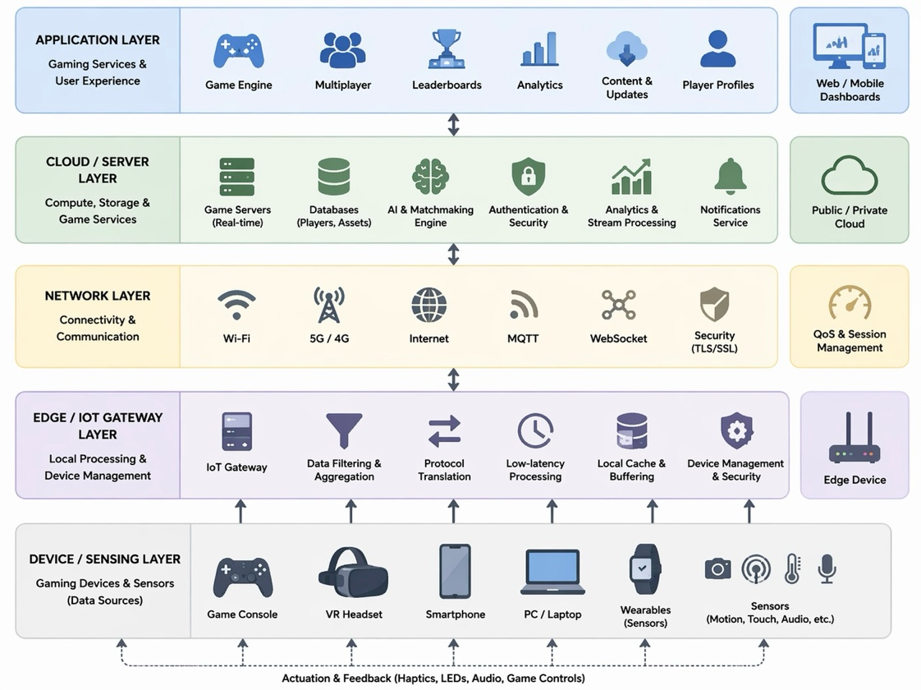
Appendix
Figure 1.1: IoT Architecture – Game Development
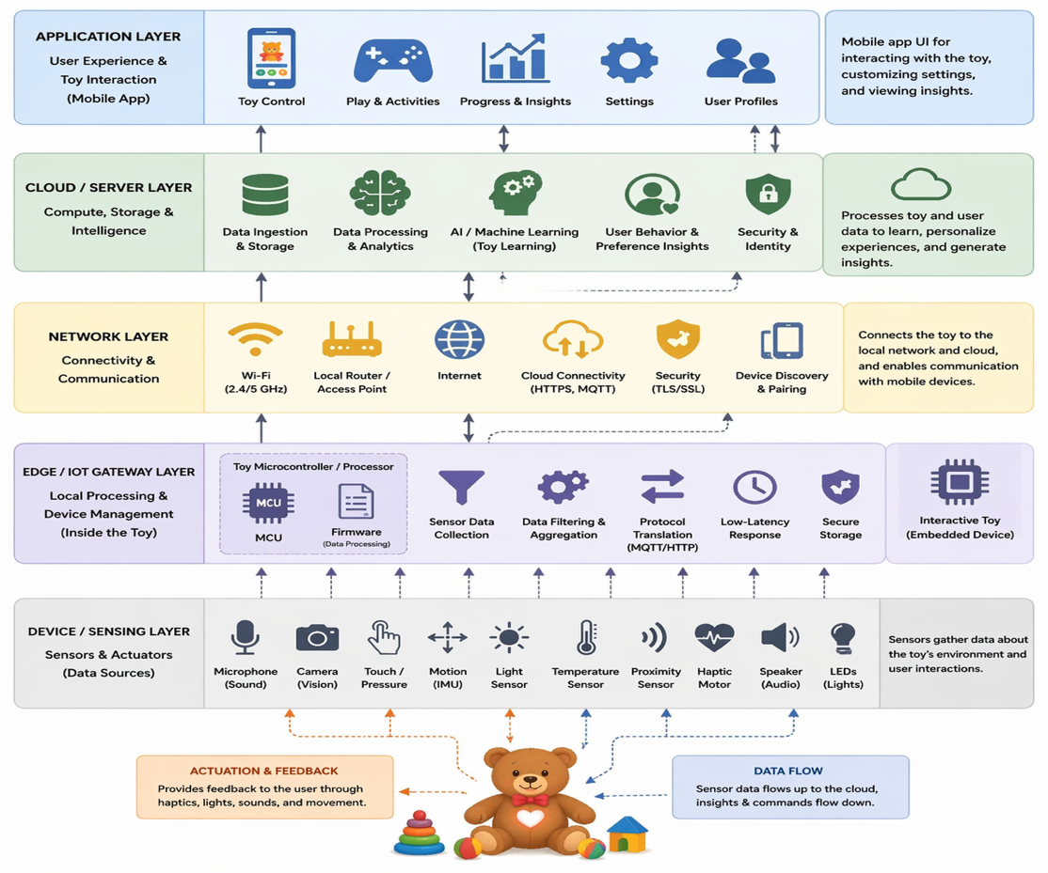
Figure 1.2: IoT Architecture – Interactive Toys
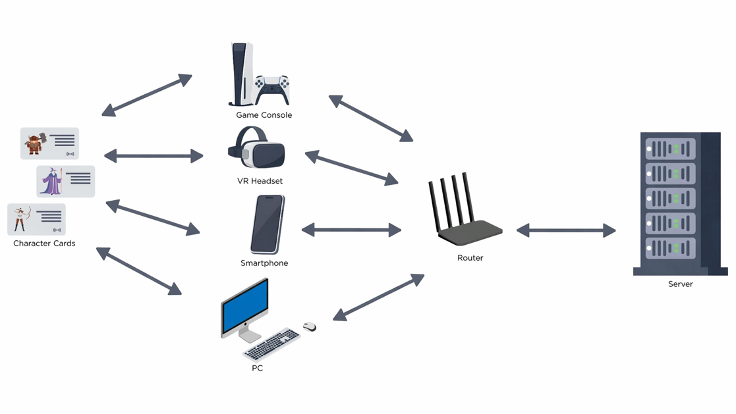
Figure 2: Game’s network architecture
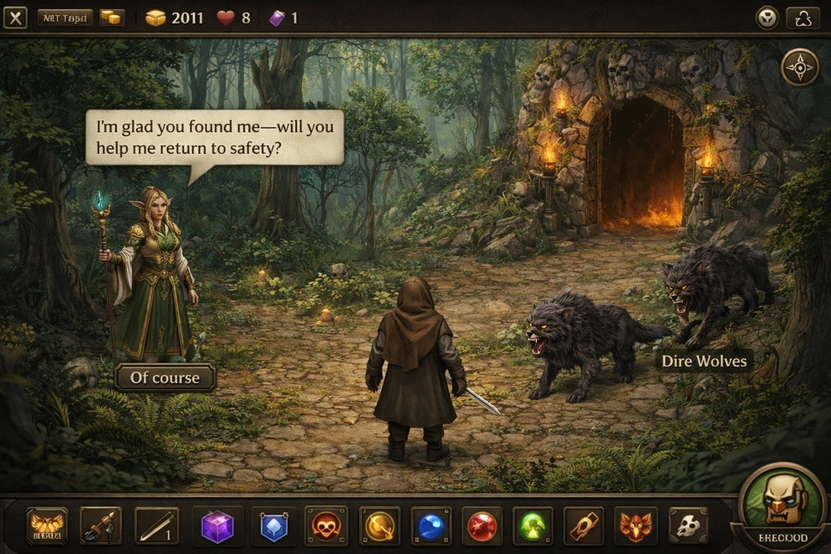
Figure 3.1: Console/PC – Forest

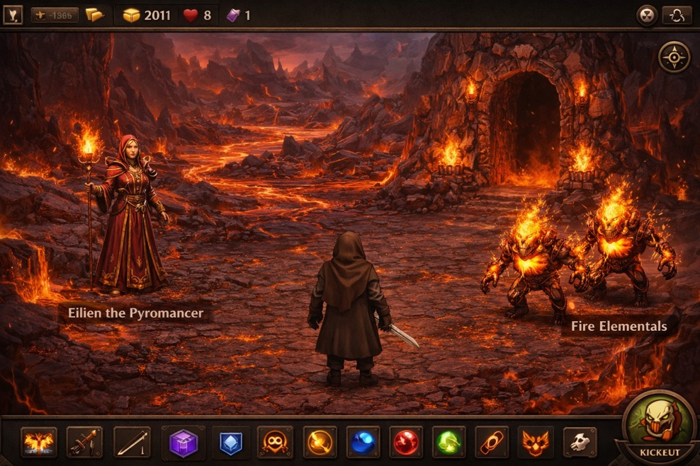
Figure 3.2: Console/PC – Muspelheim

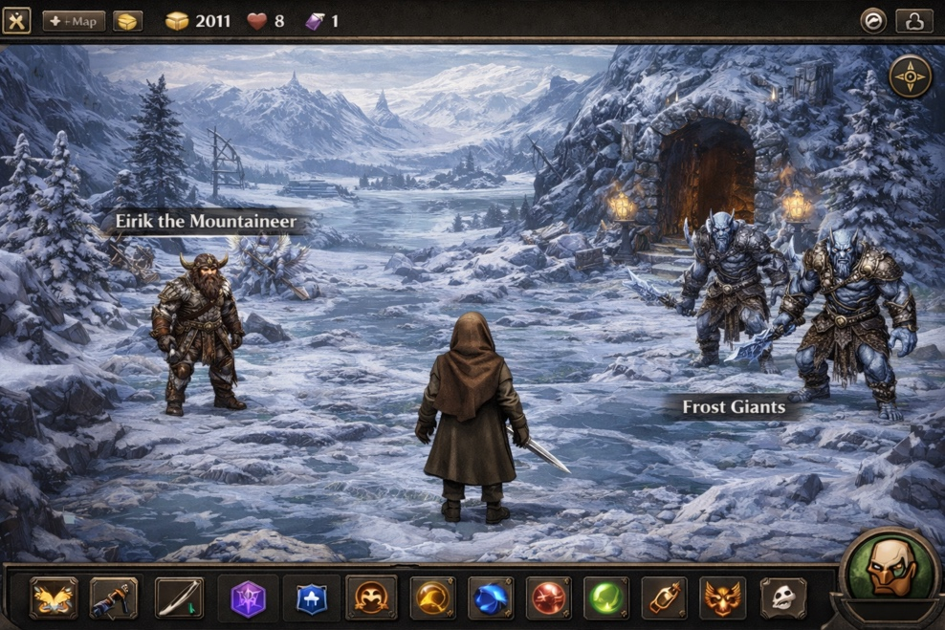
Figure 3.3: Console/PC – Niflheim

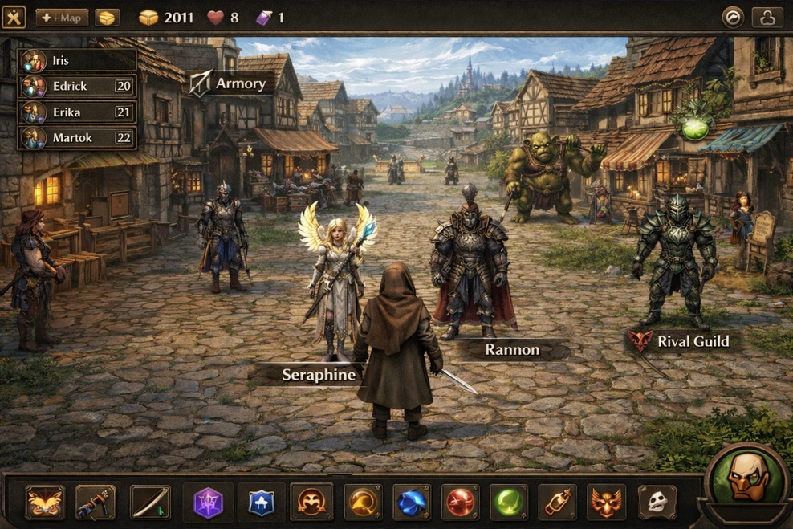
Figure 4: Console/PC – Village

Figure 5: Console/PC – Guildhall
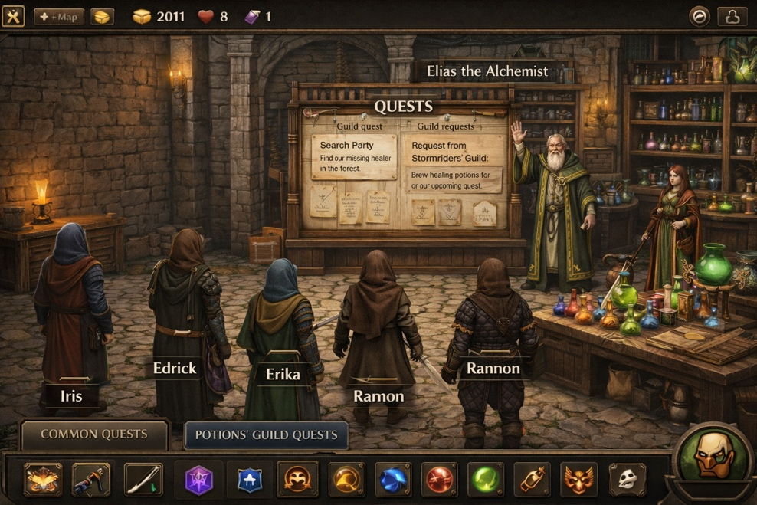
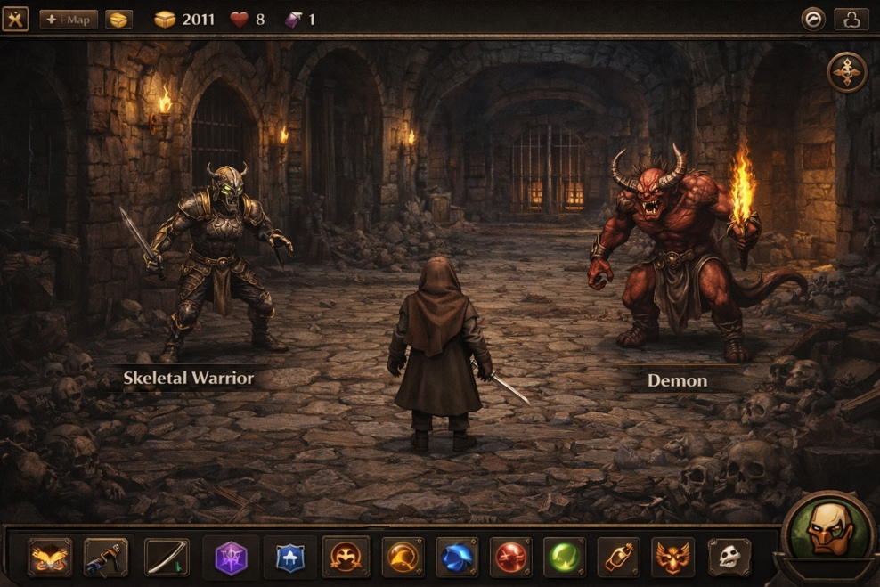
Figure 6: Console/PC – Dungeon

Figure 7: Smartphone – Raw materials, chests, and shops
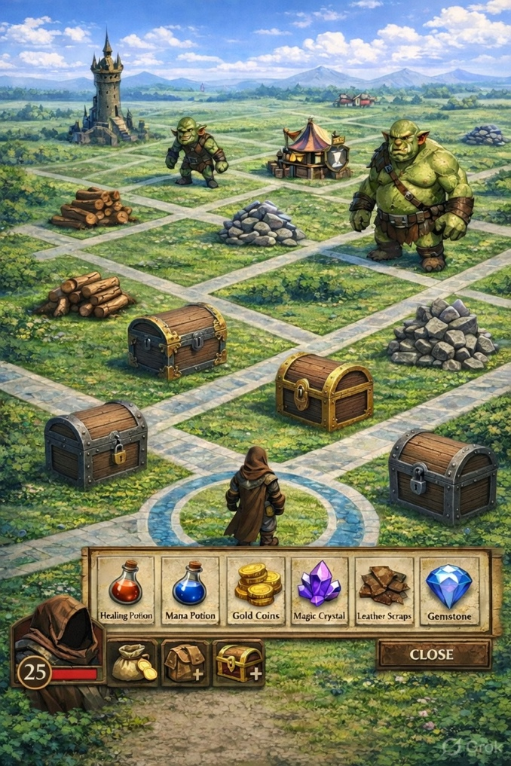

Figure 8: VR Headset – Guildhall build
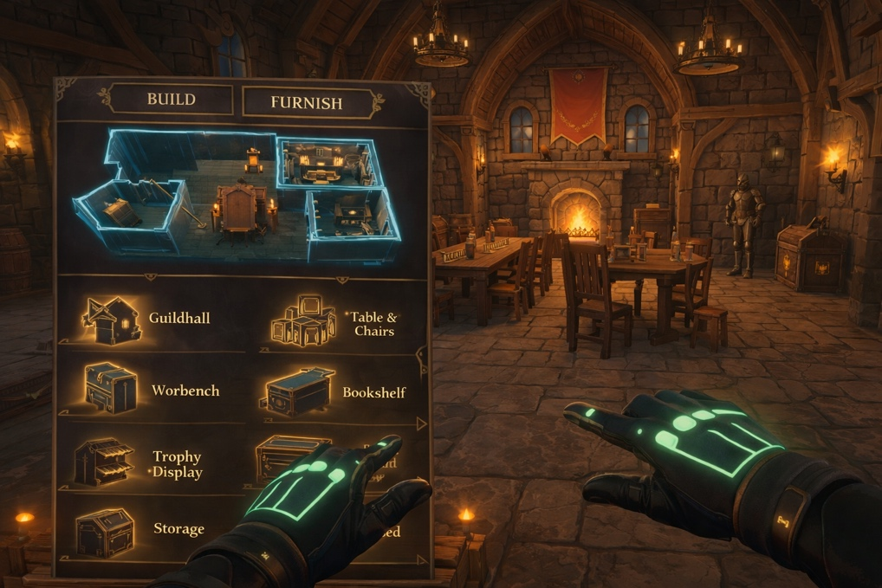

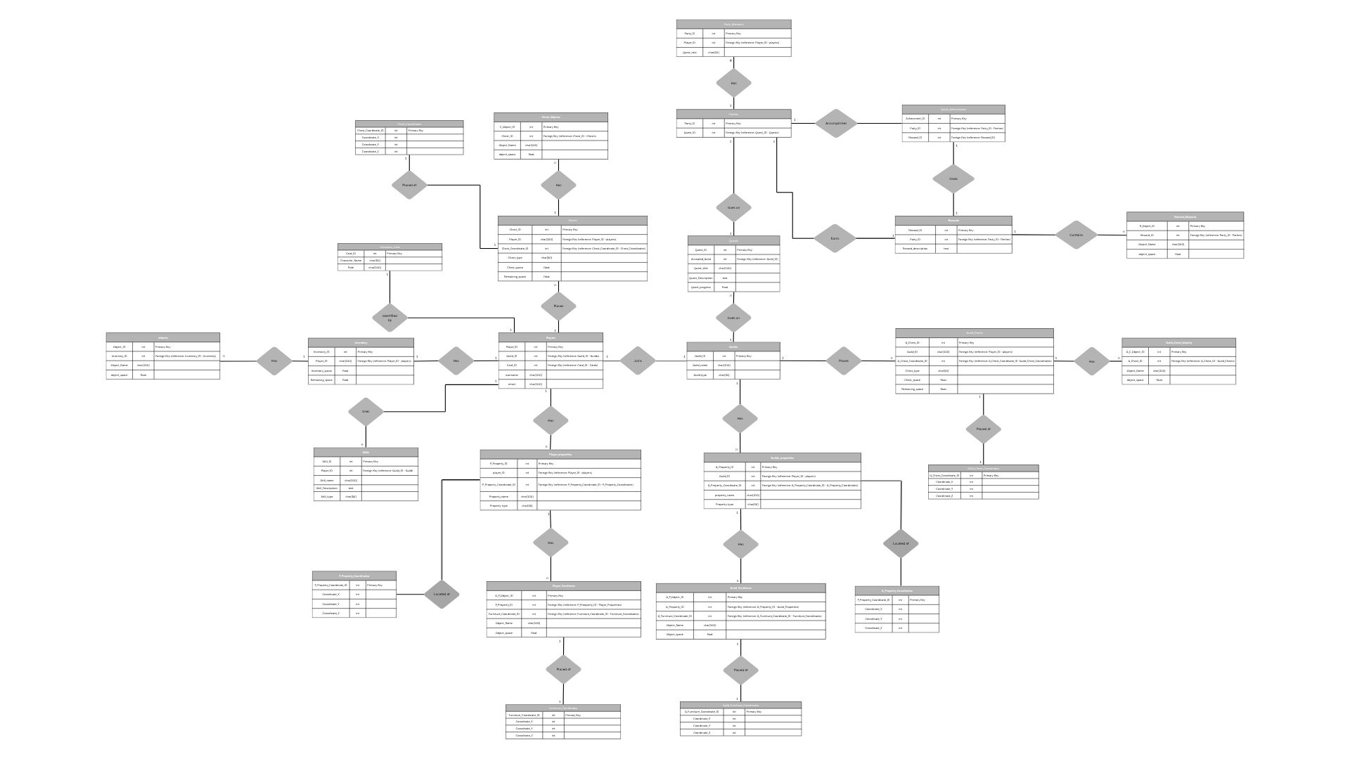
Figure 9: ER Diagram

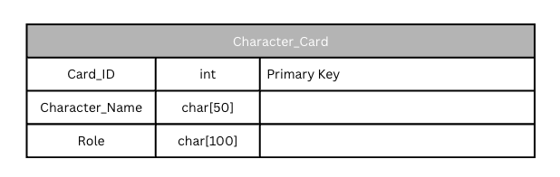
Figure 10: Database entities – character card
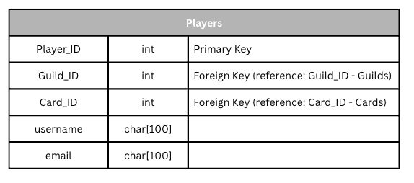
Figure 11: Database entities – Players
Figure 11.1: Database entities – Inventory
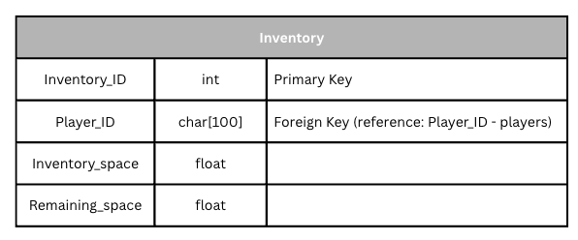
Figure 11.1.1: Database entities – Objects
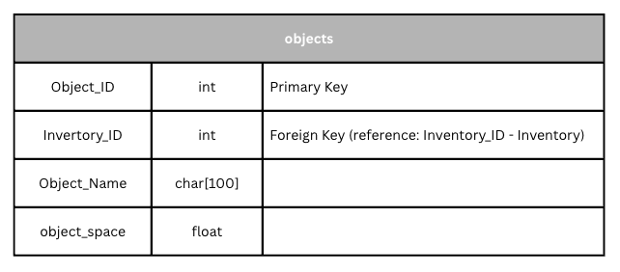

Figure 11.2: Database entities – Skills
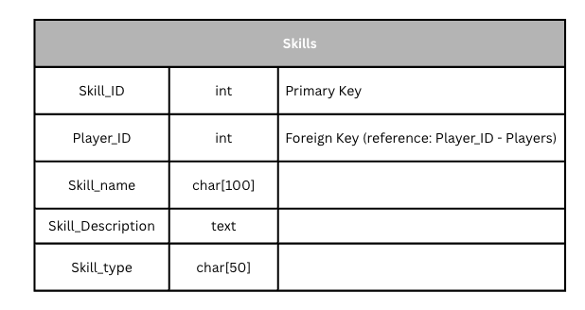
Figure 11.3: Database entities – Player properties
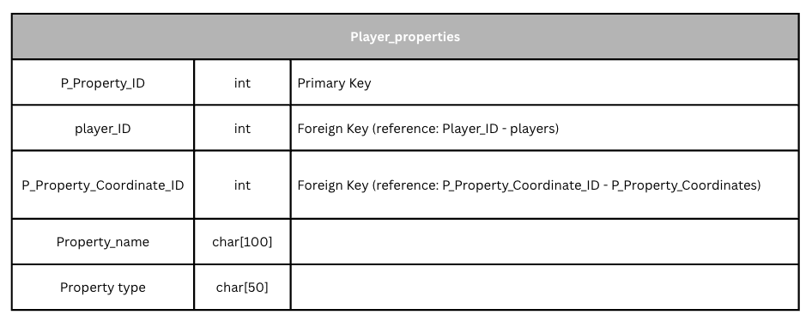
Figure 11.3.1: Database entities – Player property Coordinates
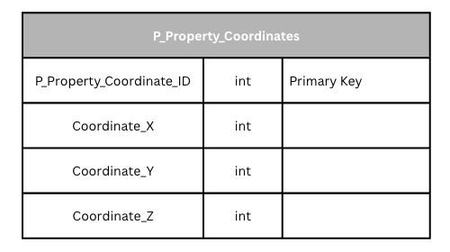

Figure 11.3.2: Database entities – Player Furnitures
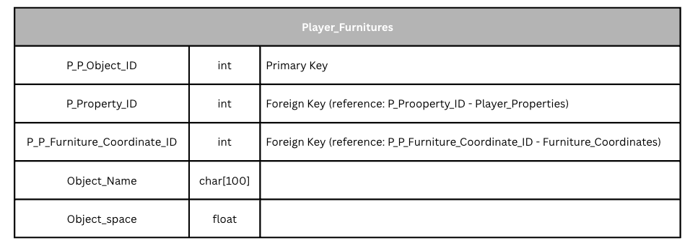
Figure 11.3.3: Database entities – Player Furniture Coordinates
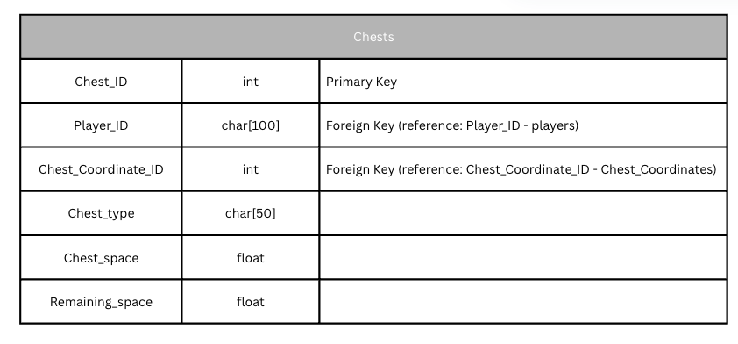
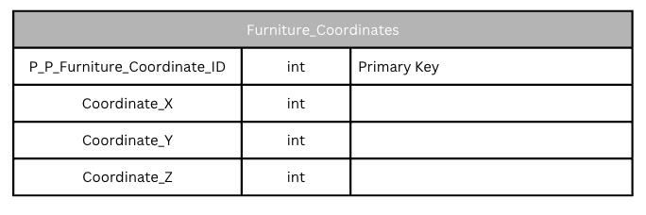
Figure 11.4: Database entities – Chests

Figure 11.4.1: Database entities – Chest Coordinates
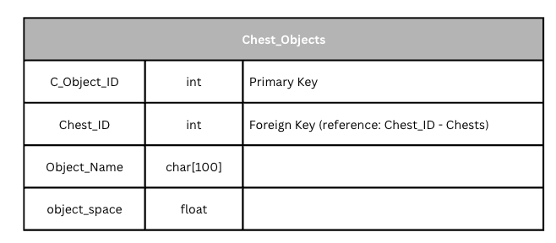
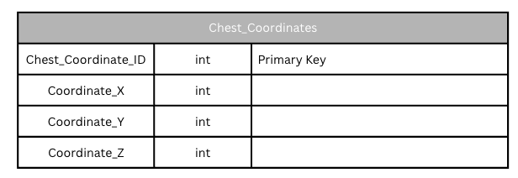
Figure 11.4.2: Database entities – Chest Objects
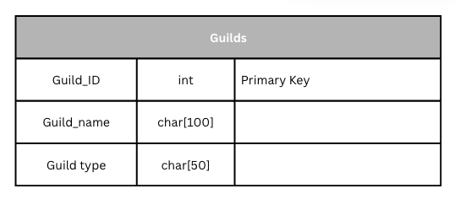
Figure 12: Database entities – Guilds
Figure 12.1: Database entities – Guilds Properties
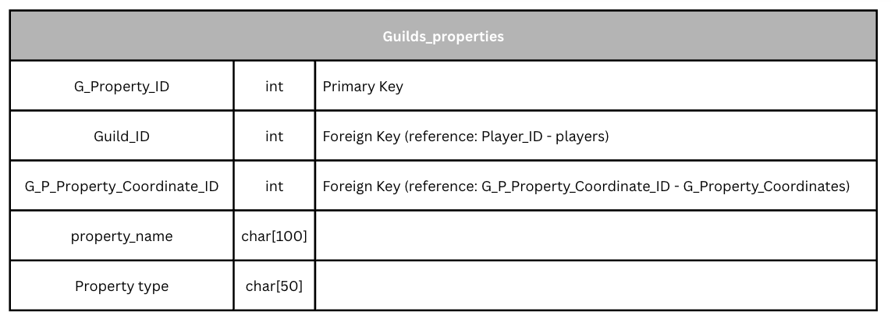

Figure 12.1.1: Database entities – Guilds Property Coordinates
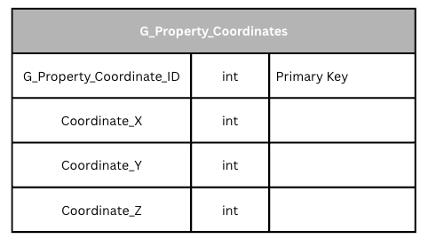
Figure 12.1.2: Database entities – Guilds Furnitures
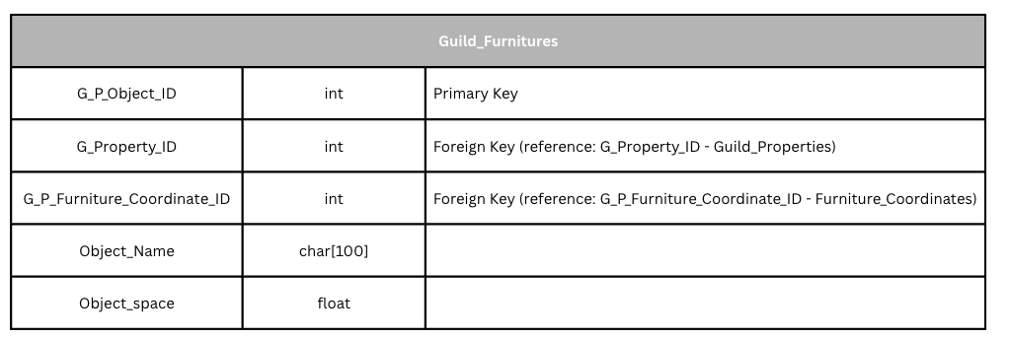Figure 12.1.3: Database entities – Guilds Furniture Coordinates
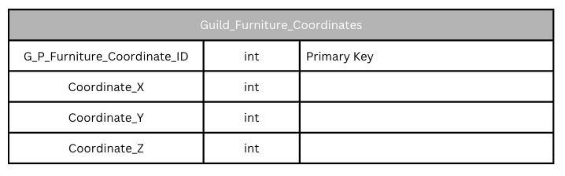
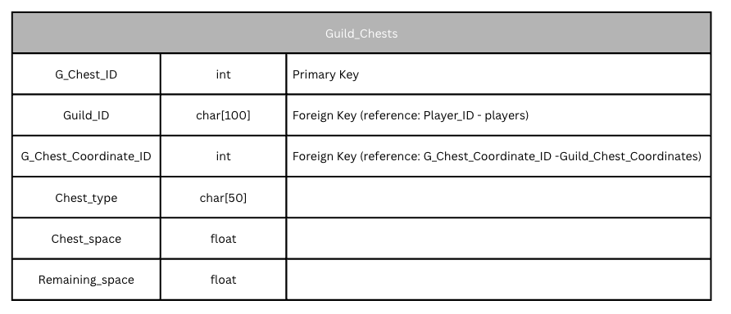
Figure 12.2: Database entities – Guilds Chests
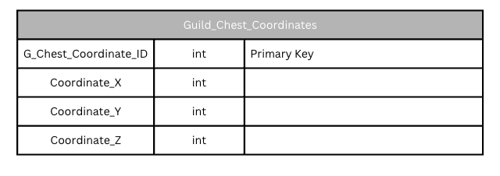
Figure 12.2.1: Database entities – Guilds Chest Coordinates
Figure 12.2.2: Database entities – Guilds Chest Objects
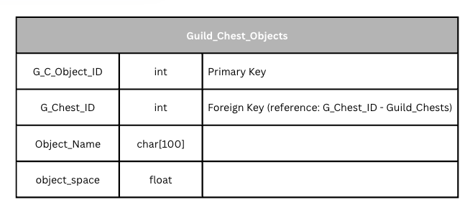

Figure 13: Database entities – Quests
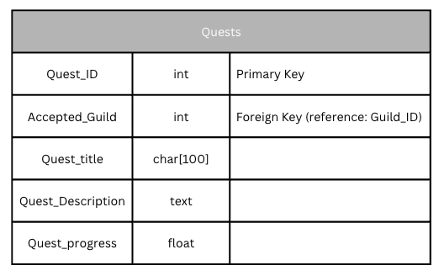
Figure 13.1: Database entities – Parties
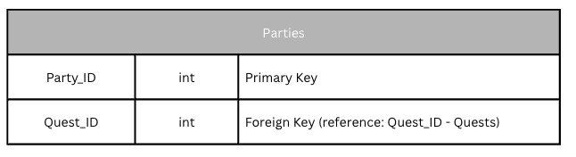
Figure 13.1.1: Database entities – Parties Members
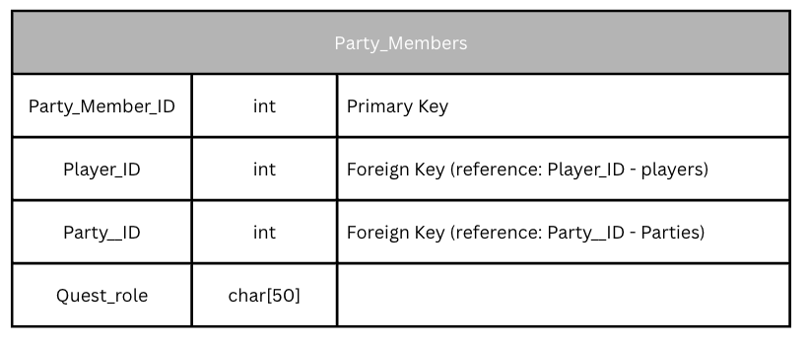
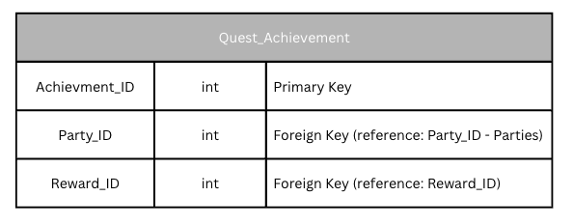
Figure 13.1.2: Database entities – Quest Achievements
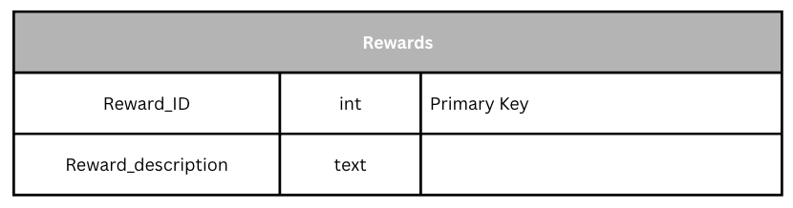
Figure 13.2: Database entities – Rewards
Figure 13.2.1: Database entities – Rewards Objects
